TOPS Technologies
N+ Network security
Assessment A2 — Complete Answers
Theme: Startup Office IT Setup
Total Time: 3 Hours

Assessment 2

Section A — Scenario-Based Concept Application

1. CPU, RAM, and Storage Selection Process
For a startup team performing software development and video conferencing, hardware selection must balance performance, compatibility, and future scalability.

CPU Selection
- Choose a multi-core processor such as Intel Core i5/i7 or AMD Ryzen 5/7.
- Higher core and thread count improves multitasking and parallel workloads.
- Verify motherboard socket compatibility before installation.

RAM Selection
- Minimum 16GB RAM recommended for concurrent applications.
- Match RAM type (DDR4/DDR5), frequency, and voltage with motherboard specifications.
- Dual-channel RAM improves performance.

Storage Selection
- SSD preferred over HDD because of faster boot and application loading speed.
- NVMe SSD provides better performance than SATA SSD.
- Select sufficient storage capacity (512GB or 1TB).

Preventing Bottlenecks
- Weak CPU with high RAM can slow processing.
- Insufficient RAM causes excessive paging.
- Slow storage delays application response and startup.

2. Resource Allocation and Hardware Bottlenecks
Background applications such as antivirus software consume CPU, RAM, and disk resources.

Performance Degradation Causes
- Real-time scanning increases CPU usage.
- Low RAM forces the system to use virtual memory.
- Disk scanning increases I/O operations.
- Multiple startup services reduce available resources.

Hardware Bottlenecks
- CPU bottleneck occurs when processor utilization remains near 100%.
- RAM bottleneck causes lag and freezing.
- HDD bottleneck results in slow file access and startup delays.

Solution
- Upgrade RAM and SSD.
- Disable unnecessary startup applications.
- Schedule antivirus scans during non-working hours.

3. Troubleshooting Peripheral Hardware Failures
When a peripheral device works inconsistently across workstations, use systematic troubleshooting.

Troubleshooting Process
- Verify physical cable and port connections.
- Test the device on another workstation.
- Check Device Manager for driver errors.
- Update or reinstall device drivers.
- Verify operating system compatibility.
- Install latest OS updates.
- Check for hardware conflicts in BIOS/UEFI.
- Test using manufacturer diagnostic tools.

Common CausesIncorrect or outdated drivers.Unsupported operating system.USB power management issues.Corrupted system files.

4. Role of UPS and Surge Protection
A UPS and surge protector protect computer systems from electrical issues.

UPS Functions
- Provides temporary battery backup during power failure.
- Allows safe shutdown of the operating system.
- Prevents sudden interruption during file writing.

Surge Protection
- Protects components from voltage spikes.
- Prevents motherboard and PSU damage.

Benefits
- Prevents file system corruption.
- Ensures data integrity.
- Reduces hardware failure risk.
- Improves system reliability.

Section B: Practical Application

Task 1: Workstation Assembly Sequence
- Install CPU on motherboard.
- Apply thermal paste.
- Attach CPU cooler.
- Install RAM modules.
- Mount motherboard inside cabinet.
- Install SMPS/Power Supply.
- Install SSD/HDD storage device.
- Connect SATA and power cables.
- Connect front panel connectors.
- Install GPU (if required).
- Verify all connections.
- Power on system and check POST.

Task 2: Troubleshoot RAM Mismatch Error
Steps:
- Enter BIOS/UEFI setup.
- Check installed RAM capacity and speed.
- Verify RAM is seated properly.
- Match RAM frequency and voltage.
- Enable XMP profile if supported.
- Update BIOS firmware if required.
- Test RAM modules individually.
- Save settings and restart system.

Task 3: LAN Topology in Packet Tracer
Devices:
- 5 PCs
- 1 Printer
- 1 Switch

Network Configuration
Network: 192.168.1.0/2
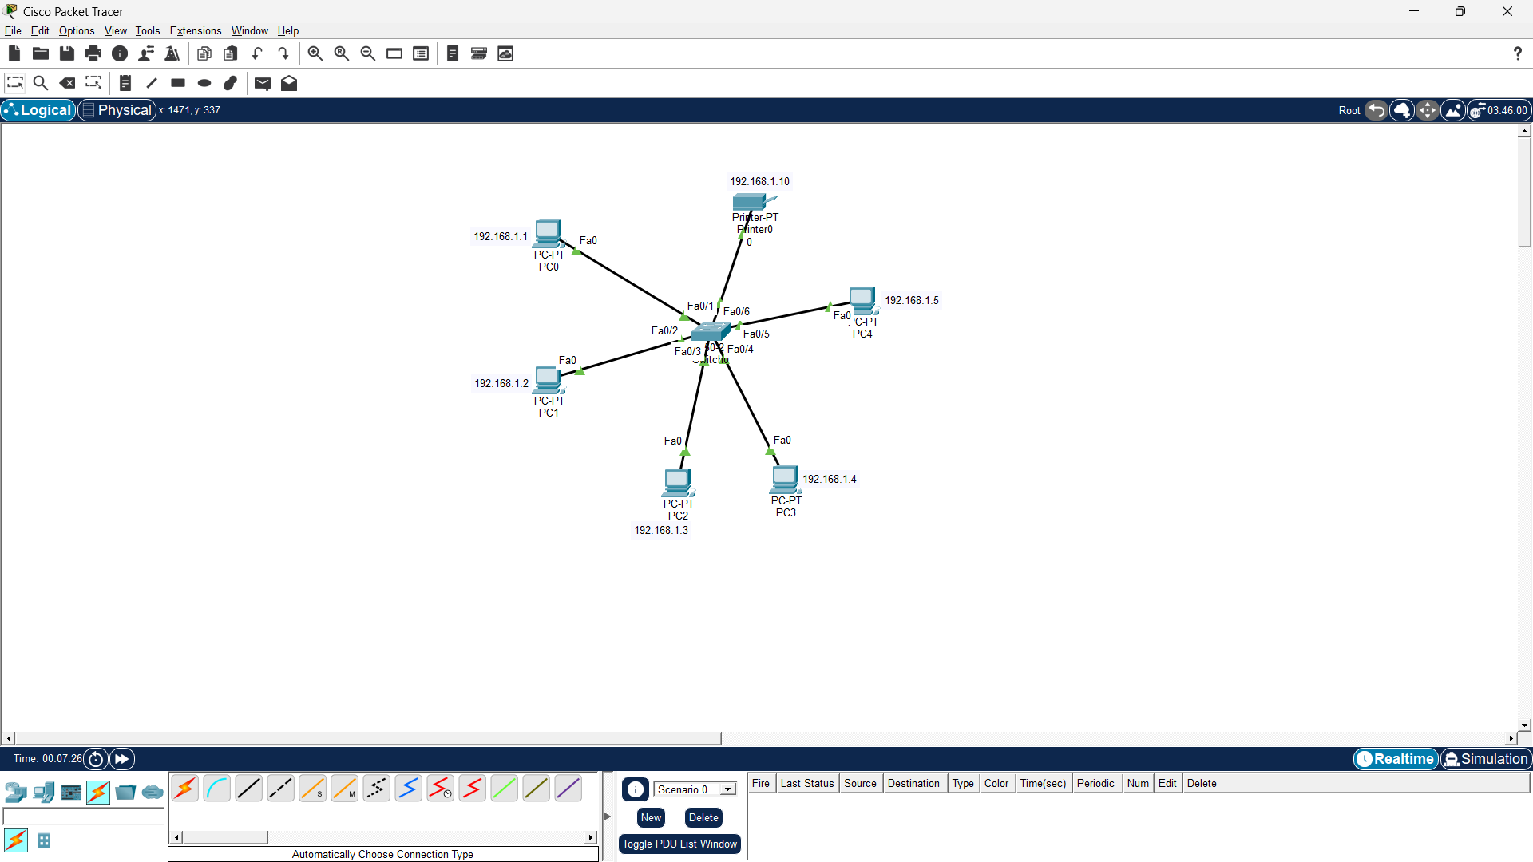

Steps:
- Add one switch and devices in Packet Tracer.
- Use copper straight-through cable.
- Configure IP addresses manually.
- Test connectivity using ping command.

Task 4: Clean OS Installation
Steps:
- Boot system using Windows/Linux ISO.
- Select custom installation.
- Create manual partitions.
- Format primary partition.
- Install operating system.
- Install motherboard and network drivers.
- Disable unnecessary startup programs.
- Update operating system.Install antivirus and utilities.

Section C — Integrated Case Study

1. Hardware Components Causing Random Reboots
The three most likely components are:
- CPU
- Power Supply Unit (PSU)
- RAM

2. Why Systems Pass POST in Morning but Fail
- LaterMorning temperatures are lower.
- Afternoon heat increases internal cabinet temperature.
- Poor ventilation traps heat inside desk cabinets.
- Overheating causes thermal shutdown and random reboots under heavy load.

3. Using Stress-Test Tools
Steps:
- Use tools like Prime95, AIDA64, or FurMark.
- Monitor CPU and GPU temperatures.
- Observe voltage stability of PSU.
- Run stress test for 20–30 minutes.
- If reboot occurs during high temperature or power draw, thermal or PSU issue is confirmed.

4. Remediation StepsImprove cabinet ventilation and airflow.
- Clean dust from cooling fans and heat sinks.
- Replace thermal paste and add additional cooling fans.

5. PSU Upgrade Justification
PSU Upgrade May Be Necessary If:
- Existing PSU wattage is insufficient.
- Voltage fluctuates during heavy workloads.
- System contains high-performance GPUs and CPUs.

PSU Upgrade May Not Be Necessary If:
- Current PSU provides stable power.
- Problem is caused mainly by overheating and poor airflow.

A quality PSU with proper wattage improves system stability and protects hardware during high power demand.

